Basic Double Bed Room  Room features:  Twin beds, TV, WIFI, Shared floor toilette and shower with Bath amenities, Slippers, Non smoking room  Location:  Room within walking distance from King's Casino  Extra beds:  Third and fourth bed subject to availability, additional charges apply | 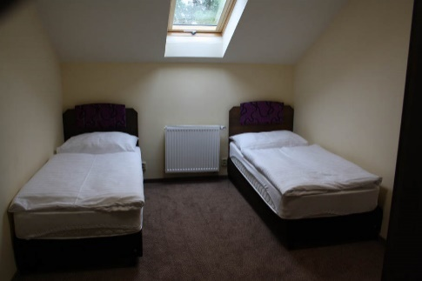
Standard Double Bed Room  Room features:  Twin beds, TV, WIFI, Shower, Slippers, Bath amenities, Non smoking room  Location:  Room within walking distance from King's Casino  Extra bed:  Third and fourth bed subject to availability, additional charges apply | 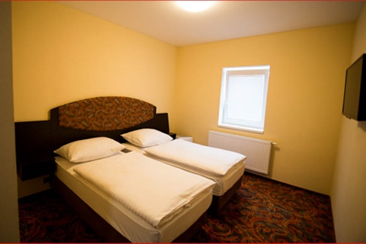
Comfort Double Bed Room  Room features:  Double or Twin beds, TV, WIFI, Minibar, Shower, Bathrobe and Slippers, Bath amenities, Non smoking room  Location:  Room within walking distance from King's Casino  Extra bed:  Third and fourth bed subject to availability, additional charges apply | 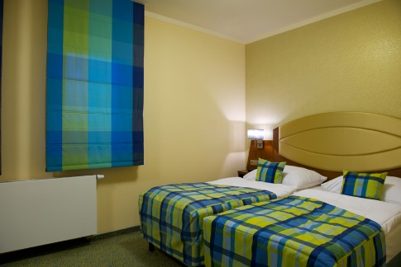
King's Superior Twin Bed Room  Room features:  Twin beds (extra long 210cm), memory foam mattress, Smart TV 40inches, High Speed WIFI, Safe, Shower, Bathrobe and slippers, Bath amenities, High Quality linen 300tc, Room temperature control, Floor Heating in Bathroom, Non smoking room  Location:  Room in King's Casino | 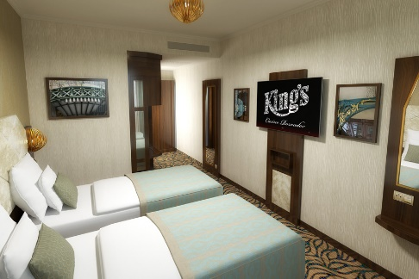
King's Superior Double Bed Room  Room features:  Double bed (extra long 210cm), memory foam mattress, Smart TV 40inches, High Speed WIFI, Safe, Shower, Bathrobe and slippers, Bath amenities, High Quality linen 300tc, Room temperature control, Floor Heating in Bathroom, Non smoking room  Location:  Room in King's Casino | 

