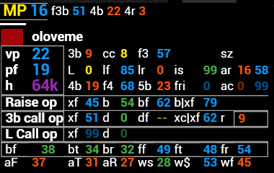

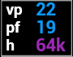 Vpip |Pfr | Hands
3bet | ColdCall | Foldvs3bet
Limp | LimpFold | LimpRaise | Isolate
4bet | Foldvs4bet | 5bet | Foldvs3Bet after isoleit
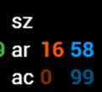 Squiz | SquizFold | AR-AsRaiser | AC-AsCaller
Raise OOP |CheckFold | Bet | BetFold | Bet\CheckFold

3BetCall OOP | CheckFold | Donk | DonkFold | CheckCall\CheckFold Reise | RaisevsCb3bet pot

Limp Call OOP | CheckFold | Donk

BetFold | BetTorn | BetRiver | FoldFlopvsBet | FolTornvsBet | FoldRivervsBet

AgrFactor | AgrFactorTorn | AgrFactorRiver | WenttoShowdown | WonatShowdown | WenttoShowdown when sow Flop

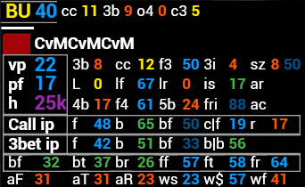

Call IP |FoldvsCB | BetvsMissedCB(Probbet) | BetvsMissedCB(Probbet) Fold | CallCb Fold |ReisevsCbet

3BetIP | FoldvsCbet | BetvsMissedCB(Probbet) 3betpot | | BetvsMissedCB(Probbet) Fold 3betpot |
BetvsMissedCB(Probbet)Flop Torn Barel 3betpot

